# **Architectural Diagram (ResearchChain)**

# Protocol POC Requirements

# 

# The protocol shall allow researchers to submit research proposals with defined milestones

# The protocol shall create an IP-NFT for each approved research proposal

# The protocol shall require researchers to deposit a 10% security deposit when submitting proposals

# The protocol shall enable contributors to fund research proposals through direct token transfers

# The protocol shall implement quadratic voting for fair distribution of research funds

# The protocol shall store research proposal data and milestone evidence on IPFS/Arweave

# The protocol shall distribute funds to researchers based on milestone completion (**No of milestones/Total Amount asked**)

# The protocol shall require validation by majority(**>50%)** validators for milestone approval

# The protocol shall penalize researchers with a 5% deposit forfeiture if milestone validation fails

# The protocol shall enable IP-NFT holders to receive royalties from commercial licensing of research

# The protocol shall distribute (x)% of license sales to the royalty pool for contributors

# The protocol shall calculate proportional royalty shares based on contribution levels

# 

## 

## 

## **Researcher Workflow**

* Account creation consists of on-chain account creation with essential state storage
* The researcher will submit a proposal with title, abstract, and defined milestones
* An on-chain proposal account will be created, storing the essential state
* The researcher must deposit 10% security funds into the escrow wallet
* Upon proposal approval, an IP-NFT will be minted to the researcher
* The researcher will submit milestone evidence to the Validation DAO
* The researcher can claim released funds after successful milestone validation
* Upon completion of all milestones, the security deposit will be returned to the researcher

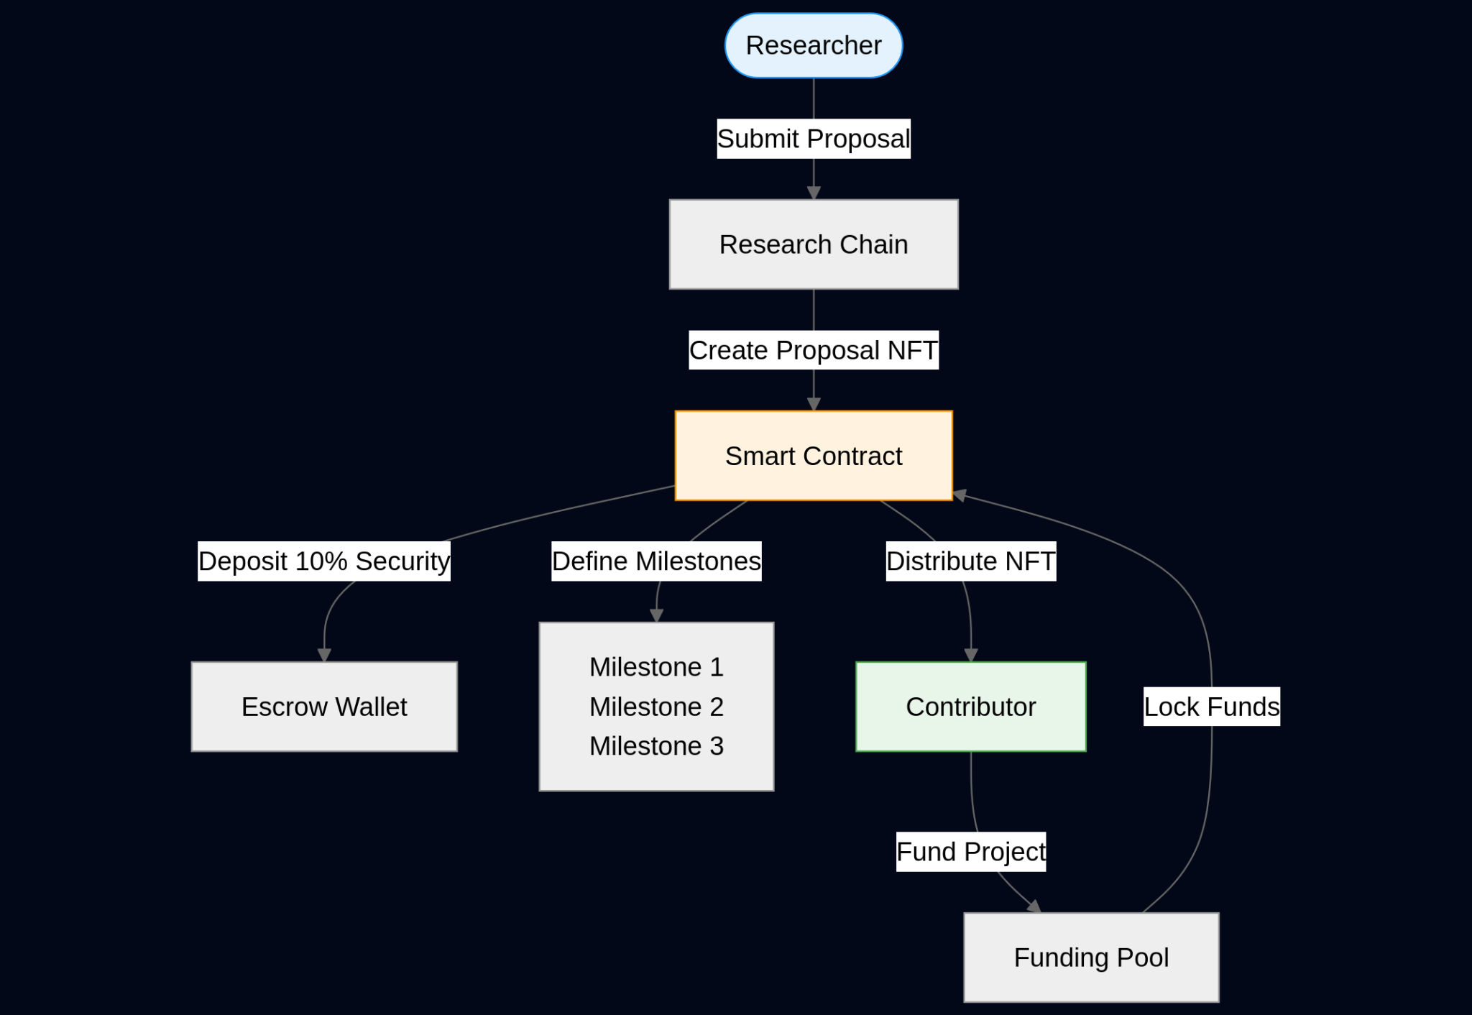

## **Validators Process**

## Validation DAO will assign a group of N validators to each milestone

## Validators must replicate research findings and submit verification reports

## Validators will vote on the validity of milestone completion

## If majority validators approve, milestone funds (Total Amount Asked / No of Milestones) will be released to the researcher

## If validation fails, 5% of the security deposit will be forfeited to the platform treasury

## Validation reports will be stored on Arweave/IPFS for permanent record

## 

## 

## 

## 

## 

## 

## **Contributor Workflow**

* Contributor account will be created, derived from each contributor's wallet address
* The contributor will be able to fund multiple research proposals
* Upon funding, tokens will be transferred to the funding escrow
* The contributor will receive a proportional share of the proposal NFT
* The contributor will be eligible for royalty distributions from commercial licensing
* The contributor can participate in governance decisions through quadratic voting

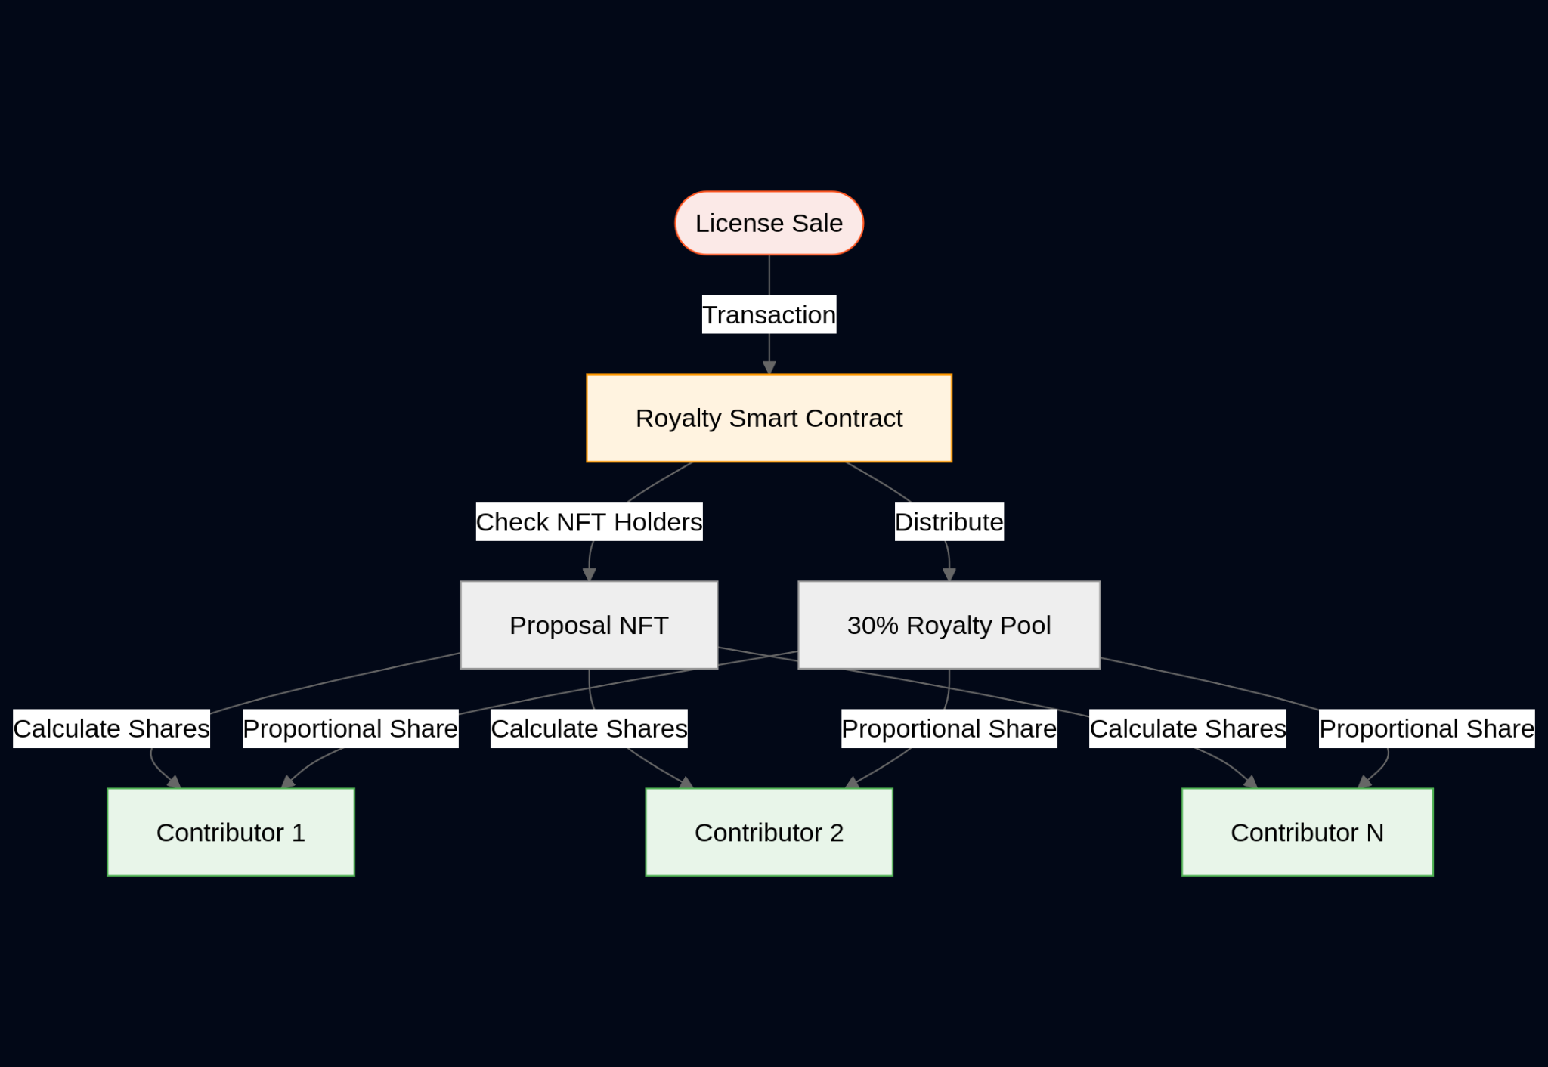

**End-to-End Overview**

1. Researcher  
    a. Submits research proposal with title, abstract, and defined milestones  
    b. Deposits 10% security funds into the escrow wallet  
    c. Uploads proposal data and datasets to IPFS/Arweave  
    d. Receives IP-NFT upon proposal approval  
    e. Submits milestone evidence for validation  
    f. Claims released funds after successful milestone validation  
    g. Receives returned security deposit upon project completion
2. Validators  
    a. Receive milestone evidence from researchers  
    b. Replicate research findings using provided data  
    c. Submit verification reports to Arweave/IPFS  
    d. Cast votes on milestone validity  
    e. Achieve majority consensus to approve milestone completion  
    f. Trigger fund release (Total Amount Asked / No of Milestones) upon approval
3. Contributors  
    a. Create on-chain accounts derived from their wallet addresses  
    b. Fund research proposals through direct token transfers  
    c. Receive proportional shares of the proposal NFT  
    d. Participate in governance decisions through quadratic voting  
    e. Monitor research progress through transparent milestone tracking  
    f. Receive royalties from commercial licensing (x% of license sales)  
    g. Calculate proportional shares based on contribution levels

**NOTE: Next Page contains the Master Diagram**

